Step 1 . Create a test metrics index.

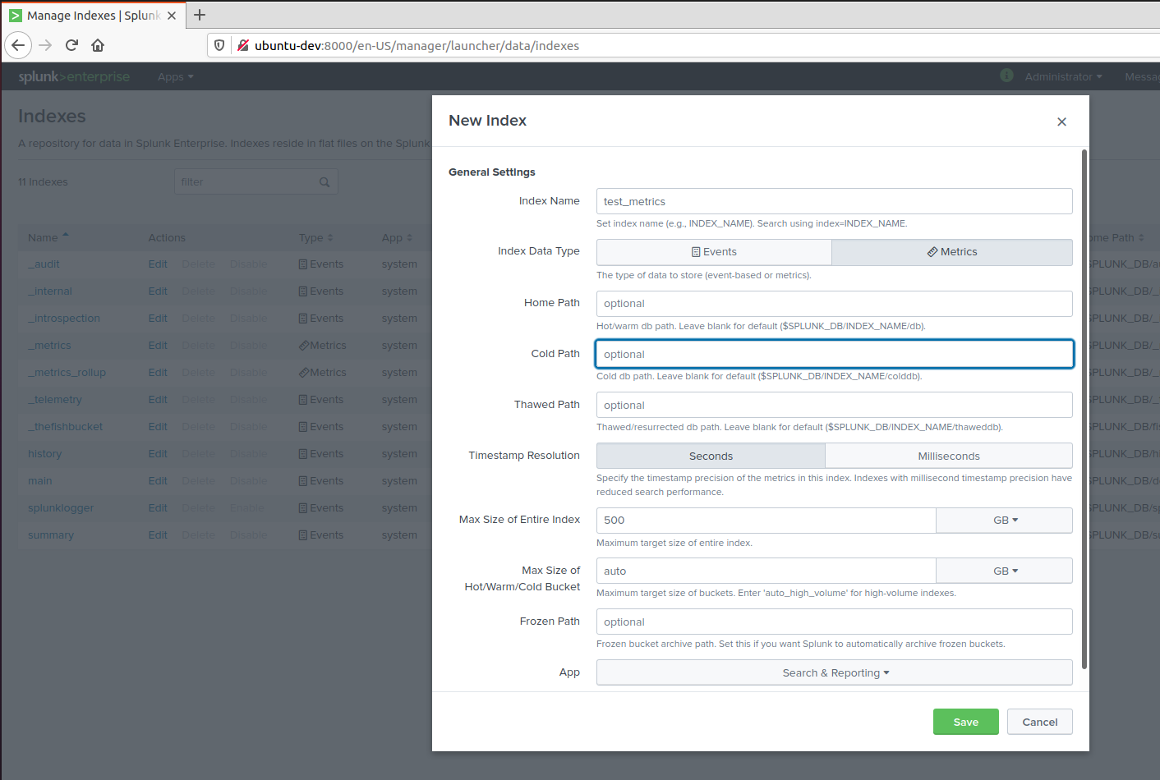

The datatype should be metrics.

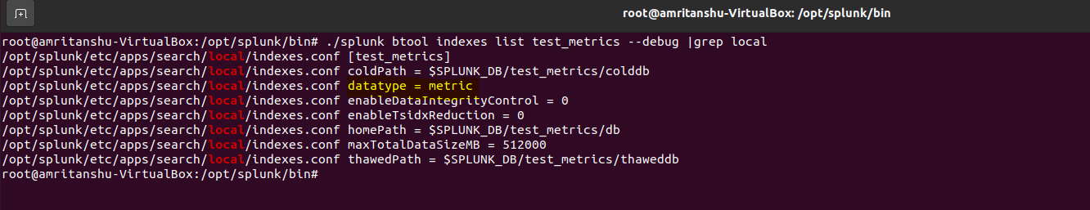

Step 2. Check the Ubuntu Version.

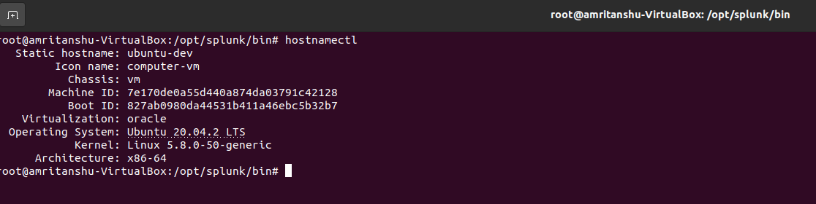

Step 3 . Check for Update : apt-get update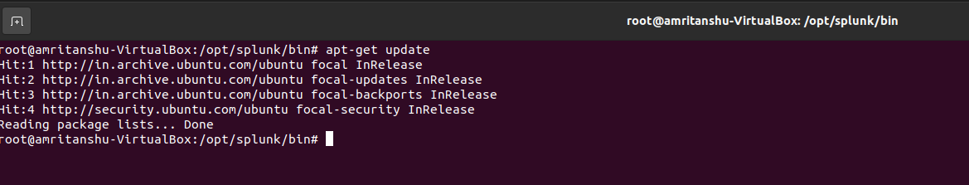

Step 4 . Validate if collectd already installed : dpkg -L collectd

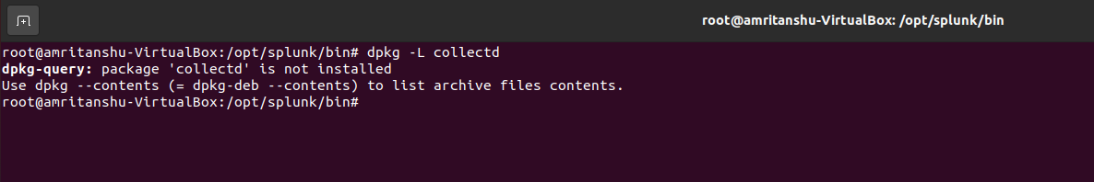

Step 5. Choose the collectd version according to OS. There are different versions of collectd, you can check what suits your OS requirements.

Help Link: <https://docs.splunk.com/Documentation/InfraApp/2.2.3/Admin/collectdSourceCommands>

Step 6. Choose the version of collectd which matches your OS from the above-mentioned Link.

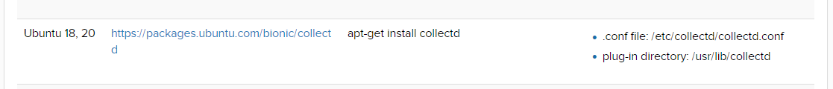

Step 7. Install collectd: apt-get install collectd

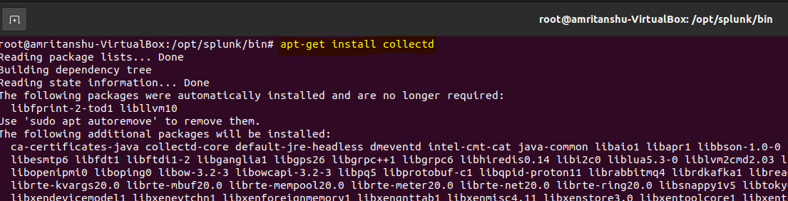

Step 8. Validate collectd version, .conf file directory, plug-in-directory according to the path specified based on OS.

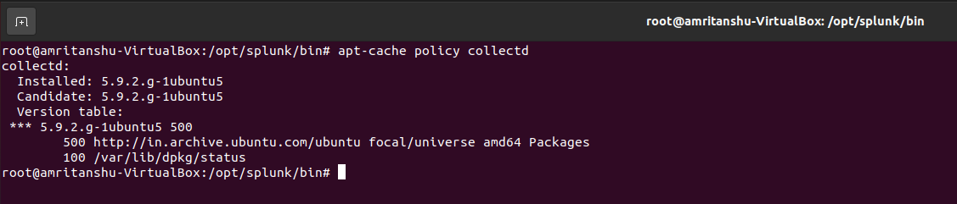

After installation collectd will be in running state – please stop it and do the changes

systemctl stop collectd

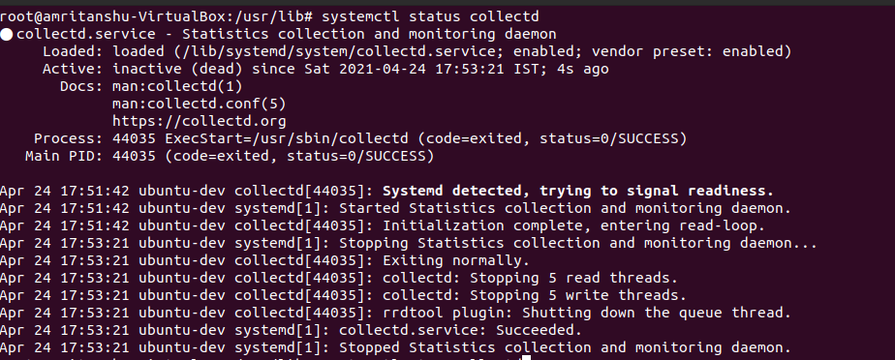

**Plugin Directory Validation :**

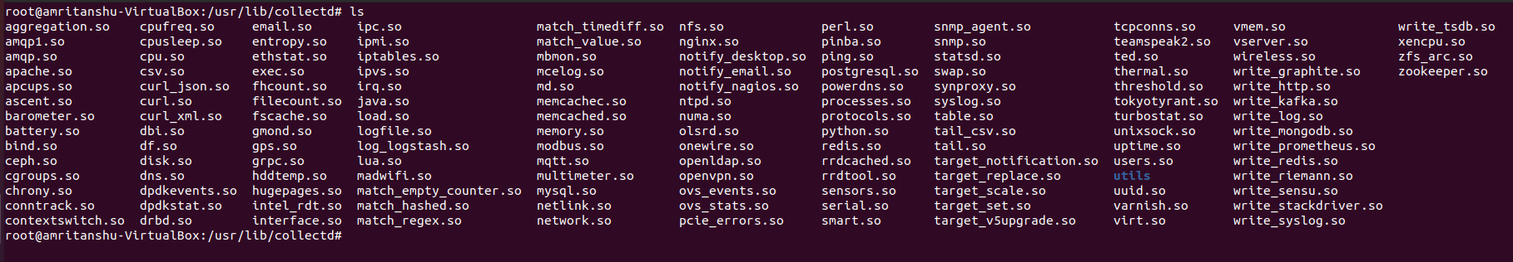

Collectd.conf Validation:

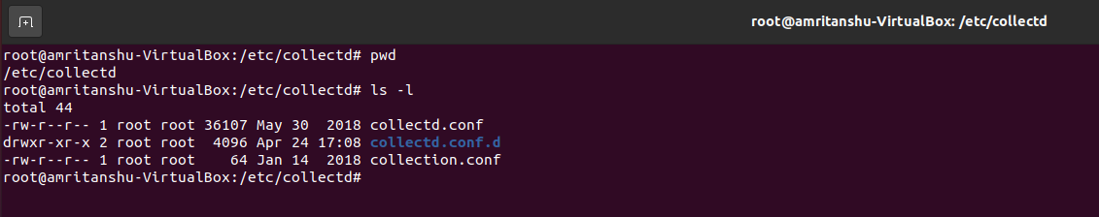

Step 9. Install libcurl package.

Help Link: <https://docs.splunk.com/Documentation/InfraApp/2.2.3/Admin/ManageAgents>

Choose appropriate package according to OS. - We will be choosing lincurl4 as suggested by the document.



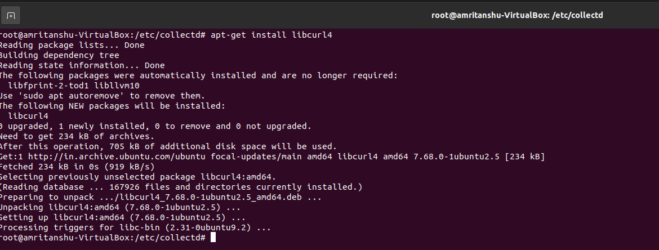

Step 10. We need to copy the Plugins into collectd plugin dir.: **/usr/lib/collectd**

write_splunk.so

processmon.so

As it does not come pre-loaded with the collectd package.

1. Choose the correct plugin, based on libcurl version and your OS.

Help Link: <https://docs.splunk.com/Documentation/InfraApp/2.2.3/Admin/ManageAgents>

Since, we have installed collectd version 5.9 and using ubuntu:

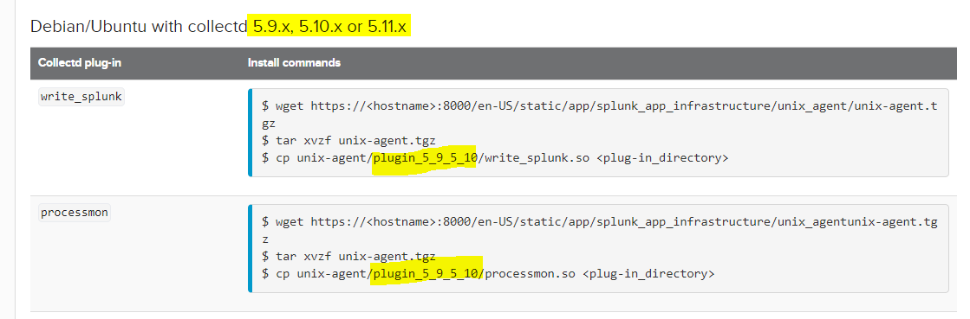

1. Validate the package in collectd plugin dir:

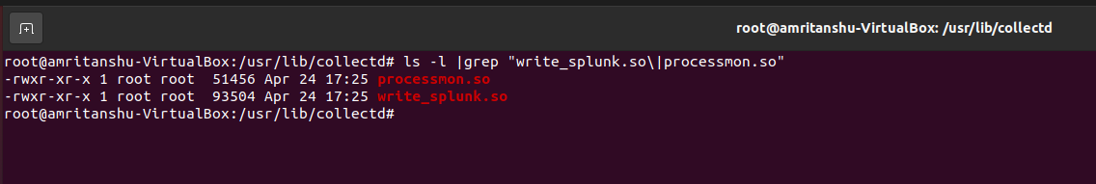

Step 11. Edit the collectd.conf located at: /etc/collectd – Load the plugins by un-hashing them and call plugins with custom settings.

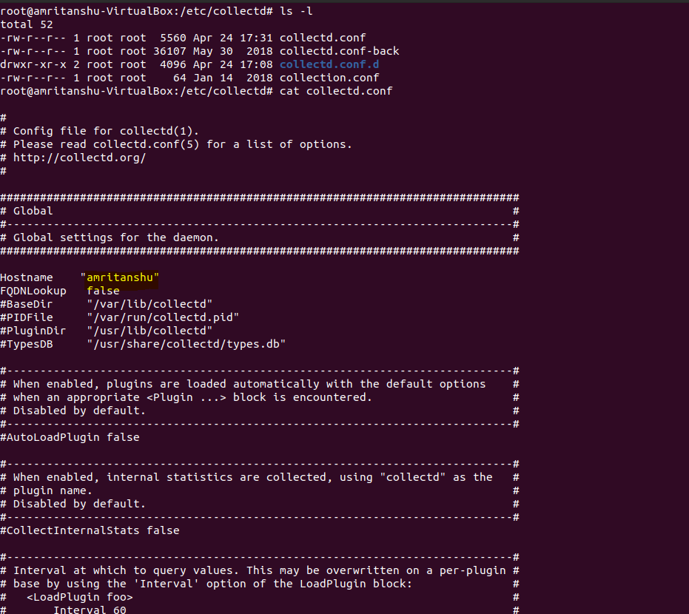

Validations for write_splunk.so plugin and processmon.so plugin loaded in collectd.conf

<Plugin processmon>

ReadIo true

whitelist "collectd"

whitelist "bash"

whitelist "splunkd"

</Plugin>

<Plugin write_splunk>

server "ubuntu_dev"

buffersize 9000

useudp true

**udpport 1970**

**Dimension "entity_type:nix_host"**

</Plugin>

Step 12. Create inputs.conf:

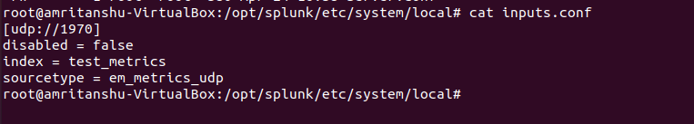

Step 13. Create props.conf and transforms.conf for **em_metrics_udp,** sourcetype – to find the metrics data point while ingestion – if not added the data will not be indexed.

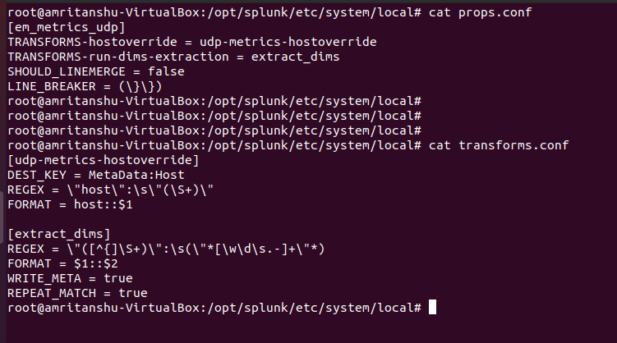

Step 14. Restart the Splunk UF. /opt/splunk/bin/splunk restart

Step 15. Restart collectd: systemctl restart collectd

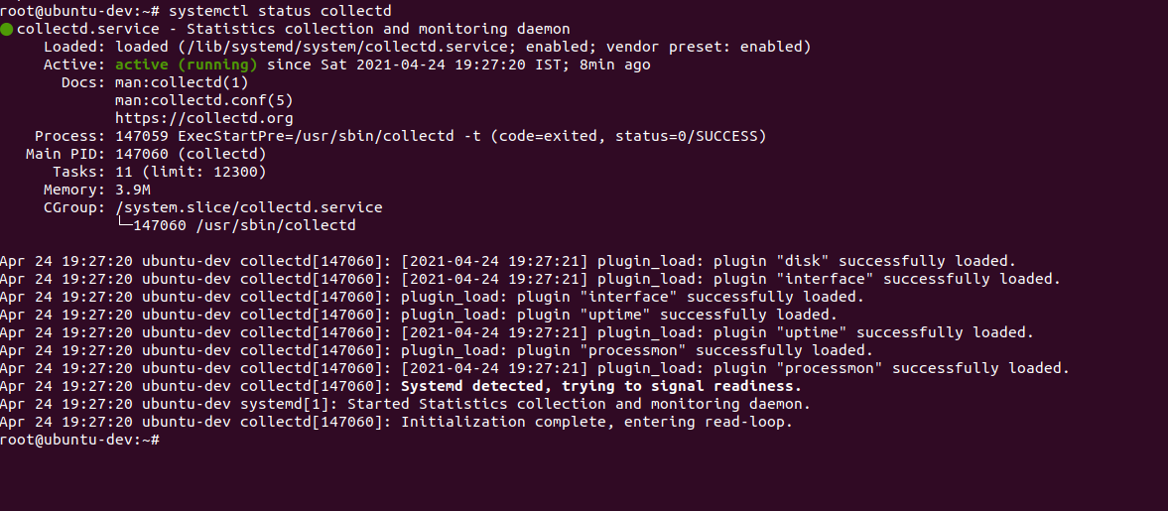

Step16. Check the traffic on udp port 1970

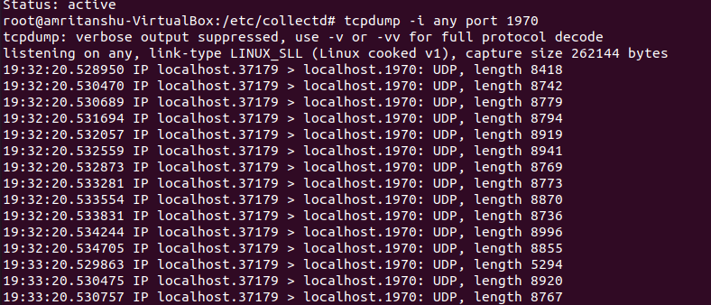

Observation: When copying the 5_7_5_8 , write_splunk.so and processmon.so

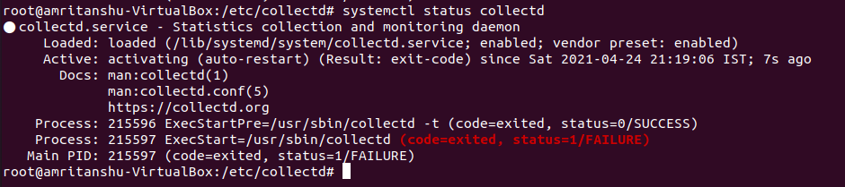

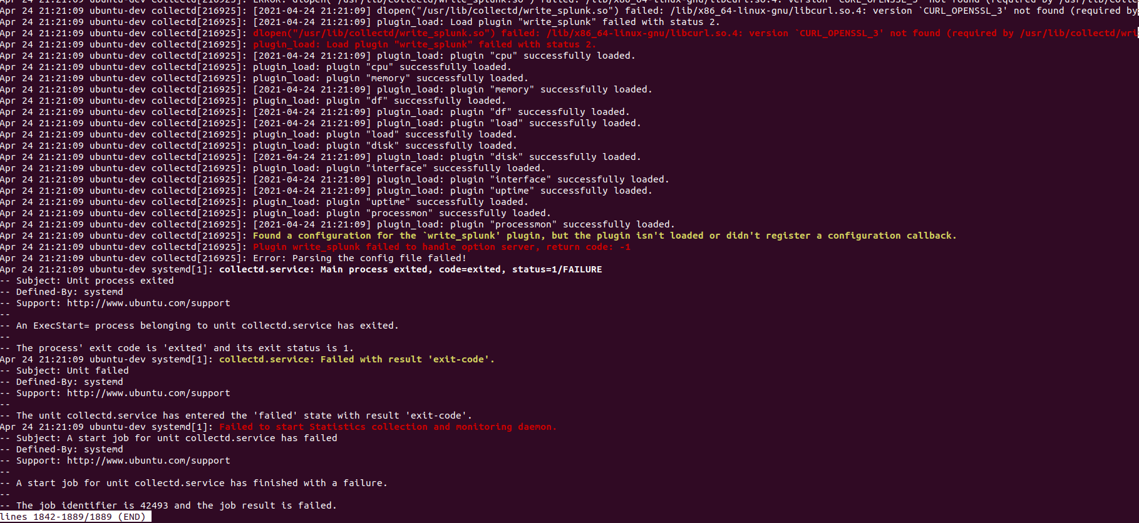

Copying the write_splunk.so from 5_9_5_10.

Just after copying the correct version the write_splunk.so starts working:

